Table of Contents
Module 1: Introducing Computers
and Operating System 1.1
Module 2: Introducing Internet and Email 2.1
Module 3: Introducing Word Processing 3.1
Module 4: Introducing Spreadsheets 4.1
Module 5: Introducing Multimedia 5.1
Module 1
Introducing Computers and Operating System
Description: Computers have become an important part of everyday life in today´s world. Many people use computers to keep records, do calculations, to search information, store pictures and music, play games and communicate with others. Computers have changed the way we work and live. This course is structured to develop technology literacy skills which involves being able to use technology such as computers to communicate, solve problems, and collect, organise and share information. The course provides you many hands-on experiences to explore and discover the basic computer applications. The objective of this module is for you to learn about the basic parts of a computer and the operating system.

Activity 1: Introducing Yourself
In this activity, you will have an opportunity to introduce yourself and meet other participants.
- On the lines below, you can list the key points you want to share with others, such as your name, occupation, interests and an interesting fact about yourself.
________________________________________________________________________________ ________________________________________________________________________________ ________________________________________________________________________________
- Introduce yourself to the group.
1.1
Activity 2: Do you Know Computers?
Let’s see what you know about computers? Answer the questions below:
- Have you seen a computer before? Do all computers look the same? Can you name some parts of the computer?
_____________________________________________________________________________ _____________________________________________________________________________ _____________________________________________________________________________
- Do you know what a computer does? What do you think a computer can be used for?
____________________________________________________________________________________________________________________________________________________________________________________________________________________________________
- Have you used a computer before? If yes, what have you used it for?
____________________________________________________________________________________________________________________________________________________________________________________________________________________________________

- Do you know what a computer application is? If yes, can you name some computer applications? Which applications have you used before?
____________________________________________________________________________________________________________________________________________________________________________________________________________________________________
- Have you heard about internet? Have you used it before? If yes, what have you used it for?
____________________________________________________________________________________________________________________________________________________________________________________________________________________________________

Activity 3: Naming the parts
A computer is an assembly of many parts working together. Before you begin using the computer, you need to learn about these basic parts of a computer. There are two main types of computers – a desktop computer and a laptop. The parts of computer are listed in the following table. Try to locate the corresponding part on your computer.
1.2

Parts of Computer
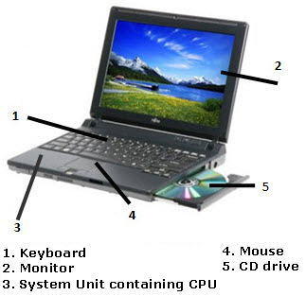
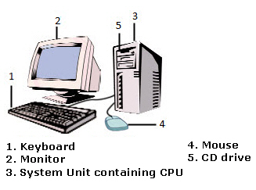

Desktop
Desktop
Laptop

The system unit is the core of a computer system. CPU (Central Processing Unit), the brain of the computer is found enclosed within a system unit. In a Desktop, the system unit is usually a separate rectangular box placed on or underneath your computer desk. In a laptop, the system unit is in-built into the body of the computer and is not a separate unit.

The monitor, like television has a screen to display information.

The computer keyboard is designed like the keyboard of a typewriter. It has keys for letters and numbers, but it also has special keys. It is used to type and give commands to the computer.

On the Desktop, the mouse is a small hand-held device that controls the pointer on the screen. A mouse usually has two buttons, a primary button (usually the left button) and a secondary button (the right button). A mouse can also have a wheel between the two buttons, which allows you to scroll smoothly through screens of information. The laptop has a touchpad which functions like the mouse. Also, on many laptops, there may be a small mouse built into the keyboard.

The CD drive is usually located on the front of the system unit in a desktop computer. In a laptop, the CD drive is located on the side of the computer. It is used to ‘read’ information from the Compact Disk or CD-ROM. The CD-ROM is the short form of Compact Disk Read Only Memory. It is used to store information for or from the computer.
1.3

Activity 4: Match the Following

Draw a line to match the Function (Column A) with its associated Computer Part (Column B), then name the computer part (Column C).

Function | Computer Part | Computer Part Name
The display device of the computer | 
The brain of the computer is found in this part | 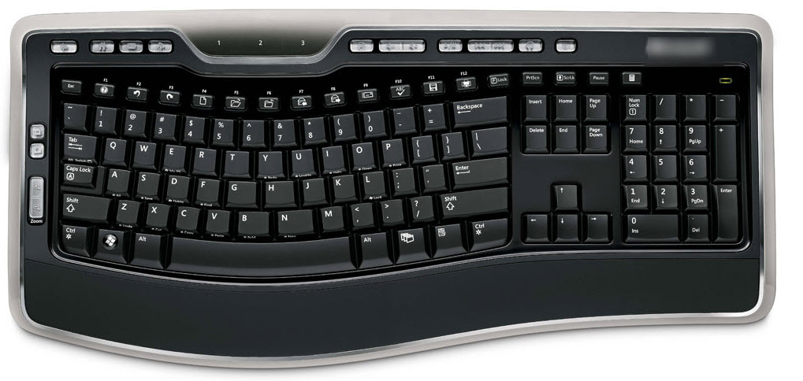
The device that helps move the pointer | 

Device used to type information
Device used to hold disks that store information | 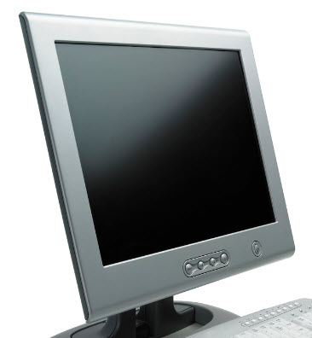

1.4

Activity 5: Turning On Computer

Turn on your computer by pressing the Power On button  on the computer.
Activity 6: Introducing Operating System
Whenever you turn on the computer, the operating system, which is the most important program in the computer, starts automatically. An operating system controls almost everything a computer does, such as recognising the input from the keyboard and mouse, sending output to the monitor, and organising and managing files and folders on the computer. There are different types of operating systems. For e.g. Microsoft Windows*, Linux, MacOS, MS-DOS, Unix, etc.
When you turn on the computer and the operating system has finished loading, the computer´s desktop is displayed on the monitor.
In this activity, we will explore Microsoft Windows*, which is one of the most popular operating system.

Step 1: Learning about Desktop
After you turn on the computer, the monitor will display a main image on the screen. This is called the desktop. The desktop is so named because it functions like a “virtual” desk workspace; it has place to work, a place to file documents, and is the location of various tools to help you complete your tasks. There are many icons or small pictures on the desktop.

1.5
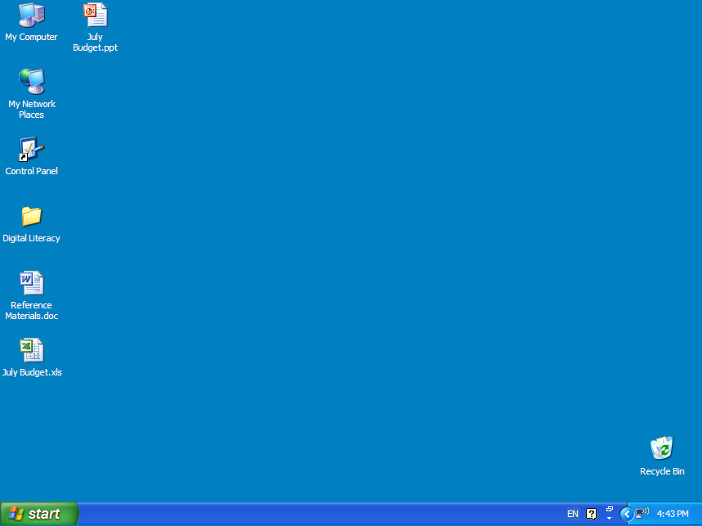
Icons are small pictures that represent some of the actions or tasks you can perform on a computer. Some of the icons represent computer software. Other icons represent places on your computer where files can be stored. Icons provide an easy way to open the programs or files you would be using on a daily basis.
What picture, or icons, do you see on your computer desktop? ____________________________________________________________________________________________________________________________________________________________________________________________________________________________________
Taskbar is the blue rectangular bar located at the bottom of the Windows desktop. The taskbar includes Start button, status area, and the systems clock.
Follow the steps to explore desktop and practice mouse movements:
- Hold the mouse gently with your index finger resting on the left button and your thumb resting on the side.
- Move the mouse by sliding it slowly in any direction. Notice that as you move the mouse, the pointer on your screen moves in the same direction.
- Click any desktop icon. What happens to the desktop icon?
__________________________________________________________________________________________________________________________________________________________
1.6
Note: Click means to point an item on the screen, then pressing the primary button (usually the left button) of mouse once and quickly letting it go. Most of the time you will be doing left clicking. As a general rule, “Click or single click” refers to clicking the primary button (usually the left button). On a laptop, the primary button on the touchpad is clicked.


Click in an empty area of the desktop. What happens to the desktop icon?
____________________________________________________________________________________ ____________________________________________________________________________________

Right click in an empty area of the desktop. What happens?
____________________________________________________________________________________ ____________________________________________________________________________________


Note: Right click means to point an item on the screen, press the secondary button (usually the right button) and release it.

Double click any desktop icon. What happens?
____________________________________________________________________________________ ____________________________________________________________________________________


Note: Double click means to point to an item on the screen and press the primary button (usually the left button) twice very quickly. Note that if the two clicks are spaced too far apart, they might be considered as two individual clicks rather than as double-click.

Click the Close button at the top right corner.

Click and Drag any desktop icon to empty area of the desktop.

Note: Drag means to point an item on the screen, press the primary button (usually the left button) and move the item to a new location and release the button. You can drag the mouse towards left, right, up or down or any other direction.

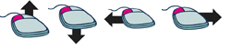

Click and Drag the desktop icon back to its original position.
1.7

Step 2: Exploring Start Menu
The desktop icons represent only the most frequently used programs and features. For more options, you need to use the Start button which is the main gateway to all your computer's programs, folders, and settings. Follow the steps to explore start menu.

- Click the Start button at the bottom-left corner of the desktop. What are some of the listed options?
_______________________________________________________________________________________________________________________________________________________________________________________________________________
- Click All Programs. What are some of the listed options?
_______________________________________________________________________________________________________________________________________________________________________________________________________________
- Click Accessories. What are some of the listed options?
_______________________________________________________________________________________________________________________________________________________________________________________________________________
- Click Notepad. It is the most basic text editor included in Microsoft Windows. 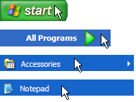
- Notice that Notepad has opened in a new window. This window is on the top of the desktop. The title bar at the top of the window shows the name of the application, for e.g. Untitled – Notepad. The taskbar at the bottom of the desktop displays the name of the program which is currently open. Notice the notepad button on the taskbar.

1.8

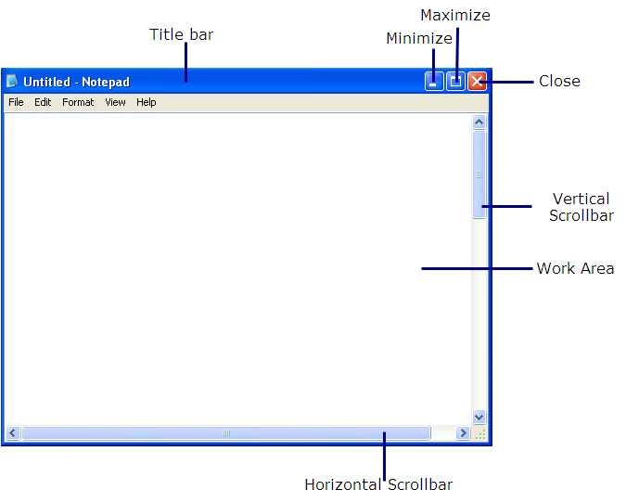
- Click the Minimize button at the top-right corner of the Notepad Window. What happens to the window?
_________________________________________________________________________________________________________________________________________
- Click the Notepad button on the taskbar at the bottom of the desktop. What happens?
_________________________________________________________________________________________________________________________________________
- Click the Maximize window at the top-right corner of the Notepad Window. What happens to the window?
___________________________________________________________________________________________________________________________________________
1.9

Step 3: Using Notepad

Notice a blinking vertical line ( | ) in the work area of the Notepad Window. It is a cursor, which shows where the text will begin.
The keyboard is the main way to enter information into the computer. There are different types of keyboards available, but basically all keyboard keys can be divided into several groups based on their functions.
- Typing keys: These keys are used to type letters, numbers, punctuations, and symbols just like a typewriter .
- Control keys: These keys are used alone or in combination with other keys to perform certain actions. The most frequently used control keys are CTRL, ALT, the Windows logo key, and ESC.
- Function keys: The function keys are used to perform specific tasks. They are labeled as F1, F2, F3, and so on, up to F12. The functionality of these keys differs from program to program.
- Navigation keys: These keys are used for moving around in documents and editing text. They include the arrow keys, HOME, END, PAGE UP, PAGE DOWN, DELETE, and INSERT.
- Numeric keypad: The numeric keypad is handy for entering numbers quickly. The keys are grouped together in a block like a conventional calculator or adding machine.
Using Typing Keys

In addition to letters, numerals, punctuation marks, and symbols, the typing keys also include SHIFT, CAPS LOCK, the TAB key, ENTER, the SPACEBAR, and BACKSPACE.
Key Name | Key Image | Function
SHIFT |  | Press SHIFT in combination with a letter to type an uppercase letter. Press SHIFT in combination with another key to type the symbol shown on the upper part of that key.
CAPS LOCK |  | Press CAPS LOCK once to type all letters as uppercase. Press CAPS LOCK again to turn this function off.  1.10
TAB | 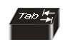 | Press the TAB key to move the cursor (the blinking vertical line (I) which shows where the text will begin) several spaces forward. You can also press the TAB key to move to the next text box on a form.
ENTER |  | Press ENTER to move the cursor to the beginning of the next line. In a dialog box, press ENTER to select the highlighted button.
SPACEBAR |  | Press the SPACEBAR to move the cursor one space forward.

Using Navigation Keys

The navigation keys allow you to move the cursor, move around in documents and web pages, and edit text. The following table lists some common functions of these keys.
Use this | Key Image | Function
LEFT, RIGHT, UP or DOWN ARROW |  | Move the cursor in the direction of the arrow or use it to scroll pages of information in the direction of the arrow.
HOME |  | Move the cursor to the beginning of a line.
END |  | Move the cursor to the end of a line.
CTRL+HOME |  | Move to the top of a document.  1.11
CTRL+END |  | Move to the bottom of a document.
PAGE UP |  | Move the cursor or page up one screen.
PAGE DOWN |  | Move the cursor or page down one screen.
DELETE |  | Delete the character after the cursor, or the selected text.
INSERT |  | Turn Insert mode off or on. When Insert mode is on, text that you type is inserted at the cursor. When Insert mode is off, text that you type replaces existing characters.

Follow the steps to use Notepad and explore different keys on your key board

Type your name using the typing keys of the keyboard. Press SHIFT key in combination with the first letter of your name to type an uppercase letter. For e.g. Raheela
- Press the SPACEBAR key to move the cursor one space forward.

Type your surname using the typing keys of the keyboard. Press SHIFT key in combination with the first letter of your surname to type an uppercase letter. For e.g. Siddiqui
- Press ENTER key to move the cursor to the beginning of the next line.
- Type your address.

(See example below)
1.12
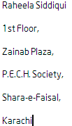
- Keep the cursor at the last letter of your name and press BACKSPACE key to delete the letter before the cursor.
- Keep the cursor at the first letter of your name and press DELETE key to delete the letter after the cursor.
- Notice the vertical scroll bar along the right side of the Notepad Window. To view the text not visible on the screen, click the Down scroll arrow. To go back to the top of the page, click the Up scroll arrow. You can also press the left mouse button and drag the rectangle on the scroll bar to display the part of the page that you want to see.
- Click the Close button at the top right corner of the Notepad Window. What happens to the window? Also, notice the change in the taskbar.
______________________________________________________________________________________________________________________________________________________
You will have an opportunity to develop your typing and mouse control skills as you complete the sample in the Guided Practice section and create samples in Self Practice section later.

Activity 7: Guided Practice
- Follow the instructions and type a paragraph about yourself.
- Open Notepad
- Type a paragraph about yourself.
(See example below)
1.13
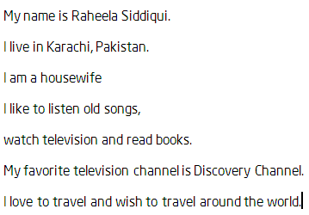
- Click the Close button at the top right corner of the Notepad Window.
- Fun with Keyboard: Open the Notepad and type the following sentences as quickly as possible. This will help you gain practice with the key board. Make note of the uppercase, lowercase and special characters.
- The Quick Brown Fox Jumps Over The Brown Fox!
- tHe fivE boXing wizArds jumP quiCkly!
- I have $28 in my Pocket; how much is it in Rupees?
- The interest is @ 13% /Annum.
- 651 is > (234 +97 - 36) & 3 is < (2*2). (2+3+8 -3) = (2*5).
- He said, “Hello, my name is Rashid Khan”.
- #Names: ‘Blue_Star’, {Flower}, [Square], ^Pup^.
- What is the difference between /,| and \?

Activity 8: Self Practice

1. Letter

In this Self Practice, you will learn how to type in your Note pad.

Type a letter to your trainer informing about your progress in using computer keyboard.

Type the letter as shown in the sample.
1.14

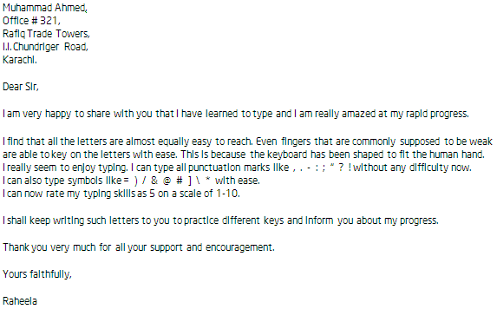
1.15

2. List of Address

In this self practice, you will practice special characters such as underscore(_),at the rate(@) and forward slash(/);punctuation marks such as colon(:) and hyphen(-) and numeric keypad.

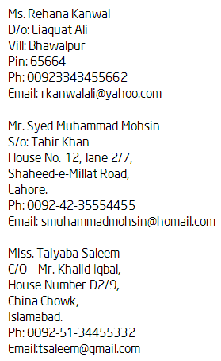

Activity 9: Creating Folders
A folder is like a filing cabinet, where you can store files and subfolders. It assists you in organising and managing your files and documents. All documents, spreadsheets and presentations relating to this course will be saved in specific folders so that you will be able to find them easily. Follow the steps to create folders on the desktop.
- Right click in the middle of the desktop, click New → Folder on the drop down menu. 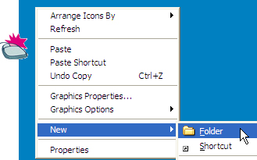
1.16
- Notice that a new folder icon appears on your desktop. 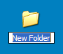
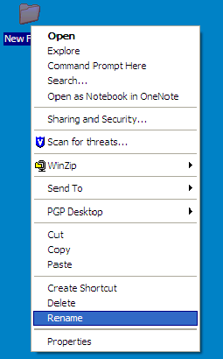
- Rename the folder by typing your first name underscore your last name. (for example, Raheela) Press Enter. If the new folder text is not selected, right-click the folder, and click Rename.

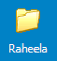

- Double-click the folder that you renamed, to open the folder. Inside, create three more folders in the same manner described above.
1.17
- Name the new folders: Word_Processing, Spreadsheet and Multimedia.
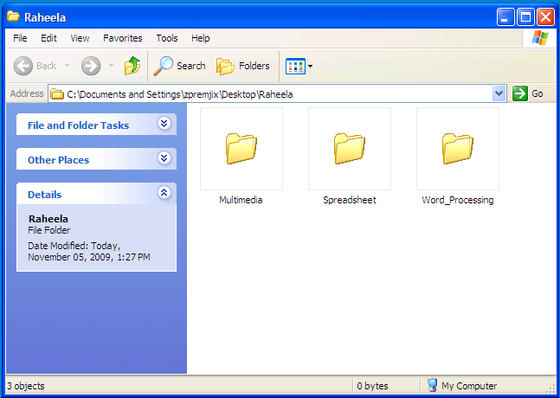
- Click the Close button in each window. You will now be able to see the desktop again.

Activity 10: Turning Off the Computer

When you have finished working on your computer, you must shut down the computer.

Follow the steps to shut down the computer using the Start menu:
- Click the Start button and click Turn Off Computer.
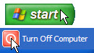
- The computer is turned off.

Activity 11: Using What I Learnt
- Given below is a list of tasks. The objective of this activity is to finish the list of tasks in the shortest time.
  - Switch on the computer (if the computer is switched on, omit this task)
  - Create the “Test” folder on the desktop
  - Open the notepad
  - Type a Welcome note for your classmates. The welcome note must mention the names of the classmates and the sentence “Welcome to the Class.”
1.18
  - Save the note in the folder “Test”.
  - Close the notepad
  - Close the folder.

- In this activity you will discuss the uses of computer in your daily life. The computer has many uses. For example, you can use computers for:
- Creating documents and presentations
- Making Calculations
- Communicating with others
- Desktop Publishing

Think about other possible uses of Computers in your day to day life. Use the space given below to list the different uses of Computers. ____________________________________________________________________________________________________________________________________________________________________________________________________________________________________________________________________________________________________________________________________________________________________________________________________________________________________
Share the list with your friends and note down any additional points.
______________________________________________________________________________________________________________________________________________________________________________________________________________________________________________________________________________________________________________________________________________________________
1.19

 Skills Set Checklist
Skills Acquired | Yes | No
I can name the different parts of a computer.
I know about the functions of different parts of a computer.
I can turn on the computer.
I can identify the different keys of keyboard.
I know functions of the keys of keyboard.
I know how to hold and move the mouse.
I can type using different keys of the keyboard.
I can use Notepad.
I know about Windows desktop.
I can identify the parts of a Window.
I can use the Start Button and Start Menu.
I can use the Task Bar.
I can create folders and subfolders.
I can turn off the computer.

1.20
Module 2
Introducing Internet and Email
Description: While searching for some information about health, jobs vacancies or entertainment through books, friends, neighbours, etc., we often end up without finding relevant information. Today, with just a click of mouse, we can get the latest information from any corner of the world right at our fingertips. And, similarly with just a mouse click, we can communicate instantly with people from anywhere in the world.

The objective of this module is for you to learn how to use the Internet effectively for searching information and communication. You will develop Internet skills by conducting an information search. You will learn how to create an Email account, send and reply to Emails. You will also get introduced to the Intel® Education Help Guide, a digital resource to help you do tasks on the computer.

Activity 1: Exploring the Help Guide

At various points during this course, you might have asked help from your friends or instructor. Now onwards, when you want any technical help, you can use the Intel® Education Help Guide. The Help Guide provides simple step-by-step directions for completing technical tasks. You can use Help Guide to quickly learn how to do certain tasks on your computer as they are needed.
Follow the steps to learn how to use the Help Guide
- Insert the Help Guide CD in the CD Drive and wait for auto run.
- Select “Open folder to view files”, and click OK.
- Double click Help Guide folder.
- Double click Help Guide.exe to start the application.
- Click the Help Guide link on the left navigation pane, which shows the contents of the Help Guide.
2.1
Note: To select a link, move your cursor over it. You will notice the cursor changes to a hand.
- Check the two main skills:
- Click Finding Technology Skills (Help Guide Skill 1.)
  - Read the instructions to find a skill in the left navigation pane. (See Help Guide Group 1.1)
  - Read the instructions to search for a skill. (See Help Guide Skill 1.2)
- Click Viewing Skills While You Work (Help Guide Skill 2.)
  - Read the instructions to view a skill in the main window. (See Help Guide Skill 2.1)
  - Read the instructions to view a skill in the individual skill pop up window. (See Help Guide Skill 2.2)
  - Read the instructions to close the pop up window and return to the main window. (See Help Guide Skill 2.5)

Activity 2: Learning Internet Basics
Before you begin using Internet, you need to learn about the basic terms related to Internet.
Internet:
The Internet sometimes called “the Net” is a worldwide network of computers, where computers across different locations can communicate with each other.
Web:
Web/World Wide Web (WWW) is similar to a library. It refers to the collection of information available on the Internet. It consists of millions and millions of pages of text, pictures, sounds and animation on various topics.
Browser:
A browser is a software program that is necessary in order for you to view Web pages on the Web, for example, Microsoft Internet Explorer*, Mozilla Firefox*, Apple Safari, Google Chrome, and Opera etc.
2.2
Web Address or URL:
A Web address (URL) refers to the address of the Web page or Web site on the Internet. It specifies the exact location of the Web page on the Internet like your detailed address including your name, house name, flat number, street name or number, city name and pin code. For example, http://www.dawn.com/wps/wcm/connect/dawn-content-library/news/pakistan

Activity 3: Exploring Web Browser
You need a software program called a Web browser to explore the information available on the World Wide Web. A Web browser is used to display Web pages on your computer. In this activity we will explore Web browsers in detail.
The Web browser consists of a title bar, a toolbar, a menu bar, a status bar and scroll bars. In addition, it includes an address bar. The address bar displays the Web address or URL of the Web page you are currently viewing. The toolbar provides navigation buttons that can be used to explore the Web.
Use Help Guide to explore Web browser.
- Start the web browser (See Web Technologies Skill 1.1 or 3.1) or double-click the web browser icon on the desktop.
- Type http://www.yahoo.com/ on the Address or Location bar. (See Web Technologies Skill 1.4 or 3.4)
Note: Make sure you type the web address correctly or else the desired web page will not open.
- Read the information and use vertical or horizontal scroll bars to view the text not visible on the screen.
- Click on any hyperlink. (word, picture or object linked to other information)
Note: You will notice that the cursor changes to a hand when it placed on any hyperlink.
- Click on the Back / Go back one page button to go back to the first page.
- Type http://epaper.dawn.com/on the Address or Location bar. (See Web Technologies Skill 1.1 or 3.1)
- Read the information and click on any hyperlink.
- Click on the Home icon on the toolbar to go to the home page of the Web browser.
2.3

Activity 4: Exploring Search Engines
Search engines are tools used to find information on the World Wide Web. Search Engines are similar to Web pages and have to be opened using a Web Browser. Usually, searches are based on a word or a combination of words or topics. The search results may consist of Web pages, images, information and other types of files (presentations, documents, spreadsheets, etc), which can be opened in a Web Browser.
Certain search engines used widely are:
http://www.google.com
http://www.bing.com
http://search.yahoo.com
http://www.altavista.com/
Follow the steps to explore search engines:
- Start the web browser (See Web Technologies Skill 1.1 or 3.1) or double-click the web browser icon on the desktop.
- Type http://www.google.com.pk on the Address or Location bar. (See Web Technologies Skill 1.4 or 3.4)
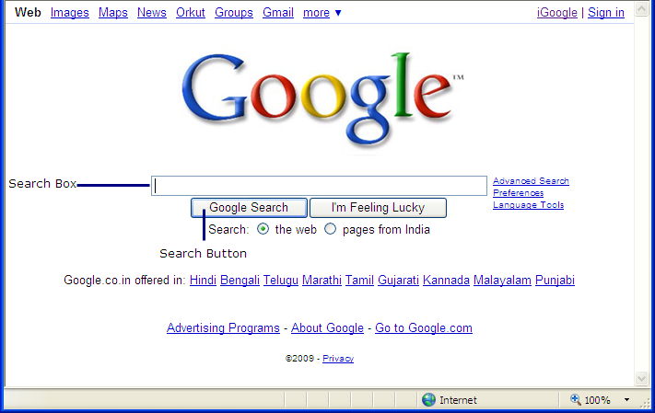
2.4

- Suppose you want to see the technology education initiatives in Pakistan, type the keywords as suggested below in the Search Box.
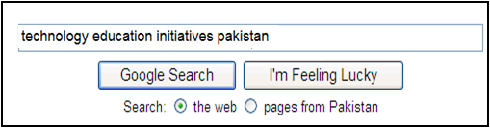
Note: Keyword is the word used by the search engines in its search for relevant websites. Choose the keywords carefully to save your time on search engines. Certain tips:
- Instead of asking the question “Who was the first man on the moon?” you can just put “first man moon.”
- Make it more specific – Instead of typing “cars”, you can just type “Nano”
- Write correct spellings of keywords.
- Avoid, “a”, “the” “is” “are”, etc. unless you are searching for some exact phrase.
- Click the Search button.
- Look at the list of links that are shown as results and click on the most relevant link. These links take you to the Web pages or Web Sites displayed in the link
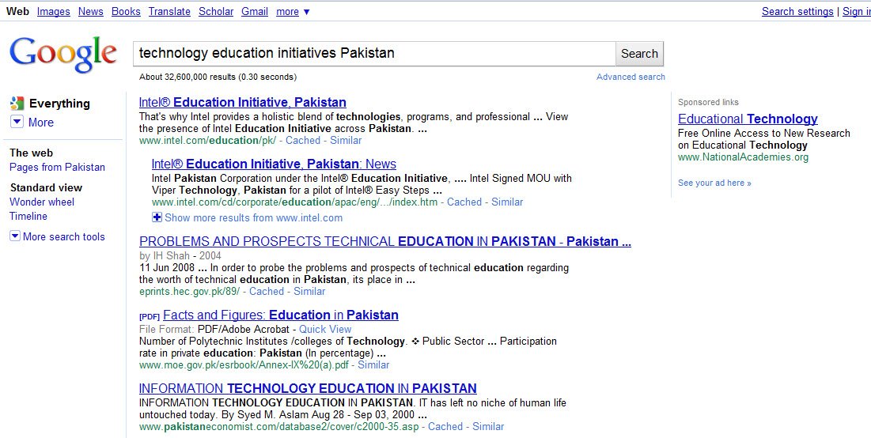
(For this search, the most relevant result link is www.intel.com/education/pk. Click on this link now.)
2.5

Note: Notice that the keywords are highlighted in the entire search result and under each website; the search engines display the phrases with the keywords. You can identify which website is relevant by reading the phrases written under each website instead of going to each one of them.


- Click Back / Go back one page button to go to the home page of the search engine.
- Type keywords about any information you want to find on Internet.
Frame your keywords in the space provided below:
____________________________________________________________________________________________________________________________________________________________________________________________________________________________________
- Click Search button.
- Look at the list of Web site and click on the most relevant website address.
- Read the required information. In case, the Web site does not have the required information, click Back / Go back one page button and click on other Web site link from the search list.
- Click on the Images link at the top of the search engine window to search for relevant images.
2.6
- Save the image in the folder Raheela you created in Module 1. (See Web Technologies 4.4)
- Click the Close button.

Activity 5: Introducing Email
In our everyday life, we often send letters to our family members or friends living in another city or abroad. With the Internet we can send our messages electronically and communicate with others across the globe in seconds. Before you start using Internet as a means to communicate, it is important to learn a few important terms.

  - Email:
An Email is a short form of “electronic mail”. It is a modern day tool to send and receive messages using the Internet.
Emails have changed the world of communication. It used to take days or even weeks to send a letter in earlier times, while now with Email you can send it in seconds or minutes. All you need is an Email account, Internet connection and the Email address of the person you are sending the Email to.

  - Email address:
Email address is a like any other address. It is unique and two people cannot have the same email address. An e-mail address typically has two main parts: The user name (raheelasiddiqui2009), the sign (@- at the rate) which is the same in every email address and mail server address (gmail.com)
There are many Email service providers like Yahoo, Rediff, Hotmail, Gmail, etc. You can create an Email ID with any service provider by registering your details. In the next step, you will create your Email ID with Gmail.
Note: There are many Email service providers but for this particular activity, Gmail is used.
2.7

Activity 6: Creating an Email ID
- Start the Web browser or Double-click the Web browser icon on the desktop. (See Web Technologies Skill 1.1 or 3.1)
- Type www.gmail.com on the Address or Location bar. (See Web Technologies Skill 1.4 or 3.4)
- Click on ‘Create an account’ to create a new Email ID.
- Fill in the appropriate information in the form.
- Click I accept. Create my account. Button.
- Record your Email ID and Password in the space provided below. Remember that the password is not supposed to be shared with anyone.
Email ID: _______________________________________________
Password: ________________________________________________
- Click Show me my account to see your account details.
- Take a look at the table below and learn about the basic features of Gmail.
Inbox | Shows all the incoming mails with details.
Sent Mail | Stores all mail sent by you.
Compose Email | To create a new mail.
Sign out | To sign out from the account

Activity 7: Sending an Email
Follow the steps given below to send an Email.
- Click Compose mail.
- Type the Email address of the person to whom you would like to send the message in the To box.
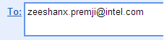
2.8

Note: In case you do not have any Email address with you, take the Email address of your friends in this course, and send a message to them. In case you want to send the message to more than one person, separate their Email addresses by inserting a semi-colon For example: ********@gmail.com; **********@yahoo.com

- Type an appropriate subject in the Subject box. 
- Type the message you would like to send. Click Send.
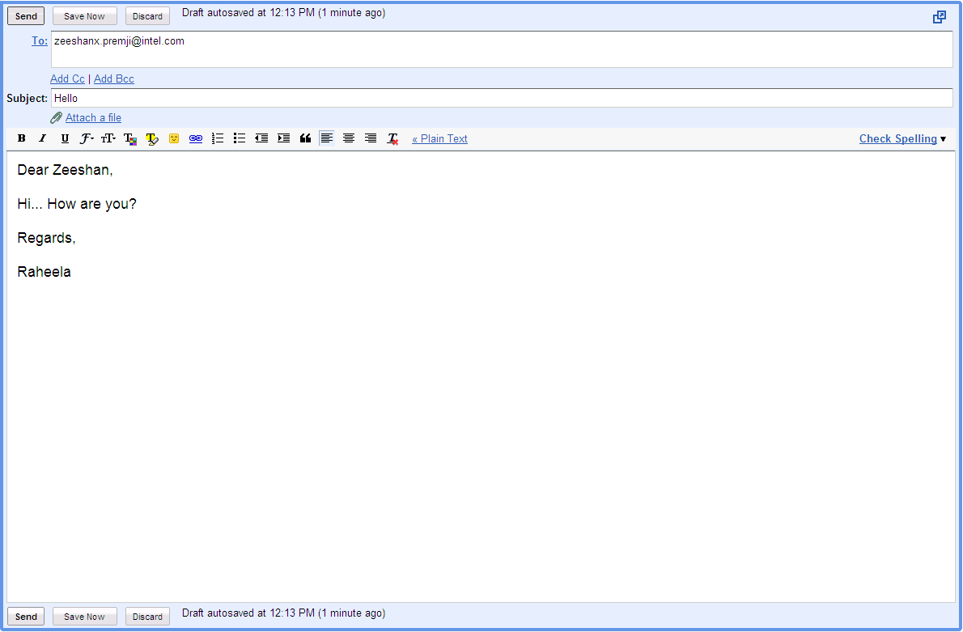
- Click Sign out.
2.9

Activity 8: Checking and Replying to Emails
You can access your Email account from any place and from any computer with an Internet connection.
- Start the web browser or double-click the Web browser icon on the desktop. (See Web Technologies Skill 1.1 or 3.1)
- Type www.gmail.com on the Address or Location bar. (See Web Technologies Skill 1.4 or 3.4)
- Type your username and password.
- Click the Sign in button.
- Click on the message you want to check.
Note: In Gmail, the incoming mails with Sender´s name and Subject of the message are already displayed on the left side.
- Click on Reply.
- The Email address of the person to whom you would like to reply comes automatically.
Note: Do not type the subject here, as it is a reply mail for the same subject.
- Type your message.
- Click Send.
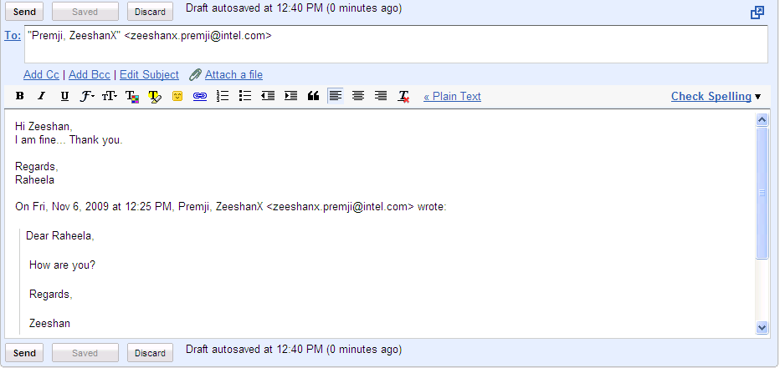
- Click Sign Out.
2.10

Activity 9: Using What I Learnt
- Use the Internet and obtain the following information. Once you have found all the information, type out the answers and email them to your trainer and your classmates:
- Go to Google.com and search for information on online shopping and write down the following:
- Keyword used: _______________; URL of the first result on the search page:______________________
- Go to http://www.xe.com/ and find the exchange rate of 1 US dollar in your currency.
Exchange rate for 1US dollar: _______________
- List one of the top news stories on http://www.express.com.pk/
News Story Title: _______________________
- Go to www.rozee.pk and write down about one job opening which you can apply to
Job Opening Title: _______________________; Company: ______________________
- Go to www.youtube.com and find a video of your choice:
Name of the video: _____________; Type of video:________________
- In this activity you will discuss the uses of internet in your daily life. The internet has many uses. For example, you can use Internet to:
- Find information
- Communicate with others
- Shop online
- Listen to music and watch videos
- Book tickets
Think about other possible uses of Internet in your day to day life. Use the space given below to list the different uses of Internet.
_______________________________________________________________________________________________________________________________________________________________________________________________________________________________________
Share the list with your friends and note down any additional points.
__________________________________________________________________________________________________________________________________________________________ _____________________________________________________________________________
2.11

Activity 10: Self Practice
- Visit the following websites
- To watch news online - http://www.express.com.pk/
- To send e-greeting cards - http://www.123greetings.com/
- To view recipes - http://www.masalatv.tv/
- To search for activities for children - http://kids.nationalgeographic.com/
- Conduct Internet search on your favourite topics.
- Send an email to your friend or relative.
- Send an email to your trainer, sharing your experience about the course and your expectations from the course based on what you have learnt so far.

Skills Set Checklist
2.12
Skills Acquired | Yes | No
- I know about Internet, World Wide Web, browser and Web address.
- I can start Web browser.
- I am able to search the Web using search engines.
- I can download and save images.
- I know about Email.
- I can check my Email account.
- I can send, check and reply Email messages.
- I can sign out of my Email account.

2.13

Module 3
Introducing Word Processing
Description: In personal or professional life, writing letters, resumes, documents, etc. is an essential activity. Writing involves drafting, checking spellings and grammatical errors, revising and editing the content. Many times, while writing letters we end up rewriting it entirely because of spelling mistakes or we end up with a rather untidy letter with many cancellations. Word processing software makes the entire process very fast and simple. It allows you to change the way words look and even insert pictures. In this module you will explore Word Processing software in detail. You will develop word processing skills by creating documents that will be useful in your daily routine.

Activity 1: Exploring Word Processing
Before you learn to use Word Processing software using the Help Guide, spend a few minutes exploring the software on your own. Try to complete the following tasks:
- Find the Word Processing software and open it
- Type your name in two different styles (different colours, different sized letters)
- Copy the typed names without retyping them
- Delete one of the typed names
- Move one of the typed names to the center of the page.
Answer the following questions once you complete the exploration:
- Were you able to complete the tasks? What skills did you learn?
____________________________________________________________________________________________________________________________________________________________________________________________________________________________________

3.1
- What kind of activities can you do using the Word Processing software?
____________________________________________________________________________ ____________________________________________________________________________ ____________________________________________________________________________
- Compare Word Processing software to writing on paper? Which is better? Why?
____________________________________________________________________________________________________________________________________________________________________________________________________________________________________
Share your answers with the rest of the class and note down points shared by your friends.
___________________________________________________________________________________________________________________________________________________________________________________________________________________________________________________________

Activity 2: Getting to know Word Processing using the Help Guide
Follow the steps to explore Word Processing skills using the Help Guide:
- Double click Help Guide icon on the desktop to start the application.
- Click the Word Processing link on the left navigation pane.
- What are some of the listed skills?
_____________________________________________________________________________ _____________________________________________________________________________ _____________________________________________________________________________ _____________________________________________________________________________
- Click Getting to Know Microsoft Word* (See Word Processing Group 1)
- What are some of the listed options?
_____________________________________________________________________________ _____________________________________________________________________________ ____________________________________________________________________________
- Open a new document (See Word Processing Skill 1.1)
Note: To view individual steps while you work, click the serial number of the skill. Click Return at the bottom of the individual pop up window to come back to the main window.

3.2
- View the different toolbars. (See Word Processing Skill 1.2, 1.3, 1.4 and 1.5)
- Type your name and address (See Word Processing Skill 2.1)
(See example below)

- Change the colour of the text. (See Word Processing Skill 2.2 and 3.4)
- Make the text of your name bold. (See Word Processing Skill 3.3)
- Increase the font size of your name. (See Word Processing Skill 3.2)
(See example below)
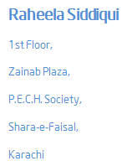
- Make Copies of your name and address without retyping them. (See Word Processing Skill 2.6 and 2.8)
- Click the Close button to close Word Processing.
3.3

Activity 3: Using Word Processing Skills
You will have an opportunity to develop word processing skills as you complete the sample in the Guided Practice section and create samples in Self Practice section later.

Guided Practice: Flyer
Flyer
Flyers are used by individuals or in business to inform people about products, events, services, or special offers. Flyers are usually single page leaflets given on the streets, at events, posted on notice boards, etc. They are also called pamphlets.

PLAN IT OUT
Imagine you run a shop and want to promote it. You make a flyer to inform people about the special offers. Look at the following sample:


Flyer example

3.4
Think about the following questions and plan your flyer.
What will you sell in your shop?
________________________________________________________________________________________________________________________________________________________________________
What will be the name of your shop?
________________________________________________________________________________________________________________________________________________________________________
List your ideas about the special offers you would like to provide on your products.
________________________________________________________________________________________________________________________________________________________________________
What will be the contact details of your shop?
________________________________________________________________________________________________________________________________________________________________________
Which images will you need to create your flyer?
________________________________________________________________________________________________________________________________________________________________________
Plan your content and layout of your flyer in the space below:
3.5
TRY IT OUT
Try to complete the following steps using the Help Guide.
A. OPEN A NEW DOCUMENT
- Start the word processing software and open a new blank document. (See Word Processing Skill 1.1)
- Save your work in the Word Processing folder created in Module 1. (See Word Processing Skill 1.7)

B. ADD TEXT TO YOUR FLYER
- Type a title at the top of the page that tells the name of your shop. (See Word Processing Skill 2.1)
- Below the title, type a few words about your shop. This could be a slogan or a catchy line.
- Make the text bigger or smaller. (See Word Processing Skill 3.2)
- Change the look of the words. (See Word Processing Skill 3.1, 3.3 and 3.4)
- Change the alignment of the words. (See Word processing Skill 4.2)
- Save your work.

C. ADD PICTURES TO YOUR FLYER
  - There are two ways you can add pictures:
- Draw your own picture with the use of drawing tools. (See Graphics Group 5)
- Add a picture from the clipart gallery. (See Word Processing Skill 5.1)
  - Move or resize the pictures. (See Word Processing Skill 5.4, 5.5 and 5.6)
  - Save your work.
3.6
D. INSERT A TABLE TO YOUR FLYER
- Insert a table to your flyer. (See Word Processing Skill 7.1)
- Type information about special offers in the rows. (See Word Processing Skill 2.1)
- Change the look of words in your table. (See Word Processing Skill 3.1, 3.3 and 3.4)
- Save your work.

E. MAKE YOUR FLYER ATTRACTIVE
- In the empty spaces on the flyer, add some more clipart pictures that show what people will find in the shop. (See Word Processing Skill 5.1)
- Add a colourful page border to your flyer. (See Word Processing Skill 6.12)

F. CONCLUDING YOUR FLYER
- Type the contact details of the shop at the bottom of the page. (See Word Processing Skill 2.1)
- Type any other information inviting people to the special offer. Change the look of words as you wish.
- Save your work.

G. PREVIEW YOUR FLYER
See how your flyer will look before you print it. (See Word Processing Skill 6.18)

3.7
Activity 4: Using what I learnt
In this activity you will discuss the uses of Word Processing software in your daily life. The software has many uses. For example, can use Word Processing for making
- Invitation Cards
- Banners
- Business Cards
- Personal Calendars

Think about other possible uses of Word Processing in your day to day life. Use the space given below to list the different uses of Word Processing.
________________________________________________________________________________________________________________________________________________________________________________________________________________________________________________________________________________________________________________________________________________
Share the list with your friends and note down any additional points.
________________________________________________________________________________________________________________________________________________________________________________________________________________________________________________________________________________________________________________________________________________

Activity 5: Self Practice
Practice your Word Processing skills by making samples using the Help Guide.

- Resume
A resume is the first step to apply for a job. Have a look at the sample and make your resume using the Help Guide.
3.8

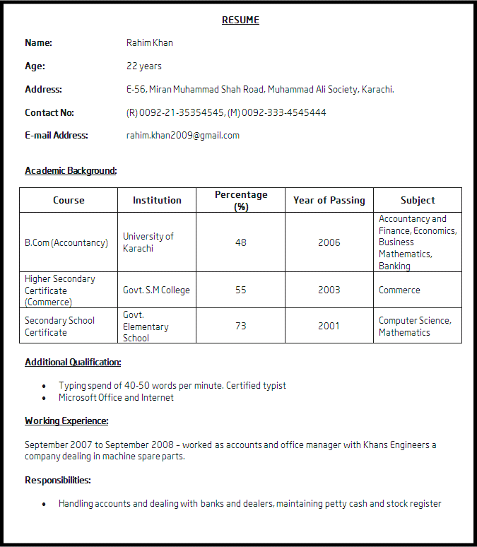
Resume example
3.9

Greeting Card
Create a greeting card to make your family or friends feel special. You can create a greeting card for any occasion birthday, anniversary, festivals, etc. Look at the sample and make a greeting card using the Help Guide.
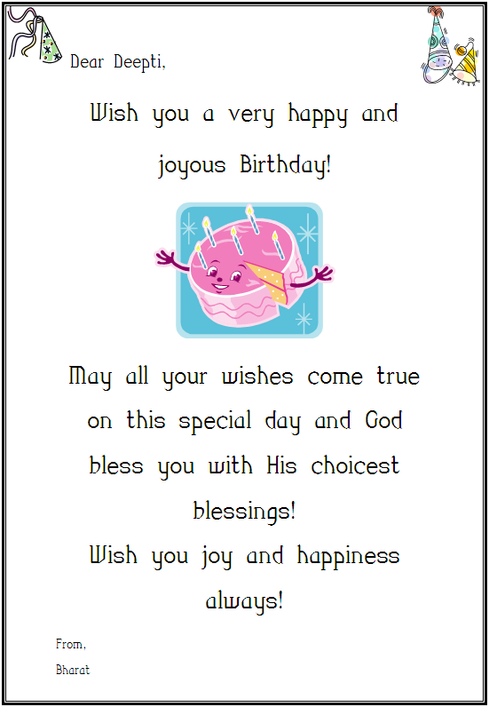
Dear Sana,
From,
Sanam
Greeting card example

3.10
Skills Set Checklist

Skills Acquired | Yes | No
I can type and change words.
I can change the colour of words.
I can change the style of words.
I can make the words bigger or smaller.
I can change the space between lines.
I can make a numbered list.
I can change alignment of words.
I can insert pictures.
I can insert tables.
I can apply page borders.
I can save a document.

3.11
Module 4
Introducing Spreadsheets
Description: A spreadsheet or worksheet is an effective tool to record all sorts of data like addresses, financial data of businesses, income and expenses, etc. It is used to perform simple to complex calculations and organise data. It can also be used to make charts and graphs.

In this module, you will explore spreadsheet software in detail. You will develop spreadsheet skills by creating worksheets that will be helpful in your daily routine. You will use the Intel® Education Help Guide to help you do tasks on computer.
Activity 1: Exploring Spreadsheets
Before you learn to use Spreadsheets software using the Help Guide, spend a few minutes exploring the software on your own. Try to complete the following tasks:
- Find the Spreadsheets software and open it
- Type 3 different words in different cells of one row.
- Type 3 different number in different cells in a single column. Add the total of these numbers below them using the “Sum” formula.
- Type all the 3 words in one cell one below the other. Make sure all the 3 words are visible.
- Change the height and width of rows 1 - 3 and columns A – C
Answer the following questions once you complete the exploration:
- Were you able to complete the tasks? What skills did you learn?
_______________________________________________________________________________________________________________________________________________________
- What kind of activities can you do using the Spreadsheets software?
_______________________________________________________________________________________________________________________________________________________
- Compare Spreadsheets software to using a calculator? Which is better? Why?
________________________________________________________________________________________________________________________________________________________

4.1

Share your answers with the rest of the class and note down points shared by your friends.
____________________________________________________________________________________________________________________________________________________________________________________________________________________________________________________________

Activity 2: Getting to know Spreadsheet using the Help Guide
Follow the steps to explore Spreadsheet skills in the Help Guide:
- Insert the Help Guide CD in the CD Drive and wait for auto run.
- Select “Open folder to view files”, and click OK.
- Double click Help Guide folder.
- Double click Help Guide.exe to start the application.
- Click the Spreadsheets link on the left navigation pane.
- What are some of the listed skills?
______________________________________________________________________ ______________________________________________________________________ ______________________________________________________________________ ______________________________________________________________________
- Click Getting to Know Microsoft Excel* (See Spreadsheets Group 1)
- What are some of the listed options?
________________________________________________________________________________________________________________________________________________________________________________________________________________________________________________________________________________________
- Open a new spreadsheet (See Spreadsheet Skill 1.1)
Note: To view individual steps while you work, click the serial number of the skill. Click Return at the bottom of the individual pop up window to come back to the main window.
- View the different toolbars. (See Spreadsheet Skill 1.2, 1.3, 1.4, and 1.6)
4.2

- Notice that an Excel window has several unique elements identified in the table below.
Row: | A horizontal group of cells in a worksheet. A Number is used to identify each row.
Column: | A vertical group of cells in a worksheet, identified by a letter.
Cell: | A Cell is an intersection point between row and column. Each Cell is assigned a name according to its COLUMN letter and ROW number. When referencing a cell, you should put the column first and the row second (e.g., Cell “A2”).

- View the Name Box (See Spreadsheet Skill 1.5)
- View the Formula Bar (See Spreadsheet Skill 1.6)
- Type “Numbers” in cell B1 (See Spreadsheet Skill 4.1)
- Type any number in cells - B2, B3 and B4.
- Type “Total” in cell A6.
- Click cell B6. Then, find sum of the numbers. (See Spreadsheet Skill 7.1)
- Type any number in cell B5. Notice the change in the total of numbers automatically.
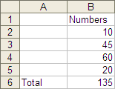
- Click the Close button to close the spreadsheet.
4.3

Activity 3: Using Spreadsheet Skills
You will have an opportunity to develop spreadsheet skills as you complete the sample in the Guided Practice section and create samples in Self Practice section later.

Guided Practice: Monthly Budget
Monthly Budget
Monthly Budget is a list of planned monthly expenses and income. Nowadays, many people prepare a monthly budget to plan for their savings and investments.

PLAN IT OUT
Create your monthly budget based on your monthly income and expenses. Look at the following sample.

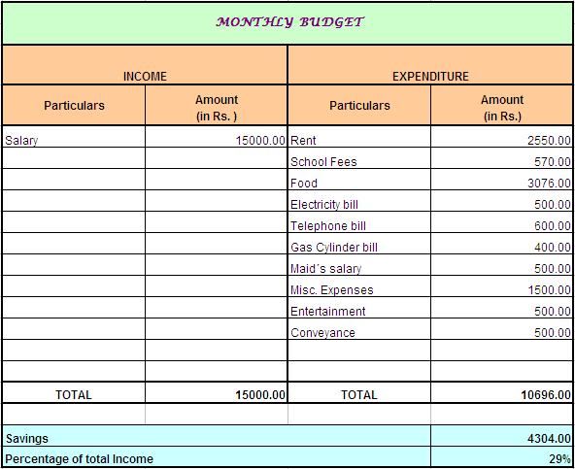

4.4
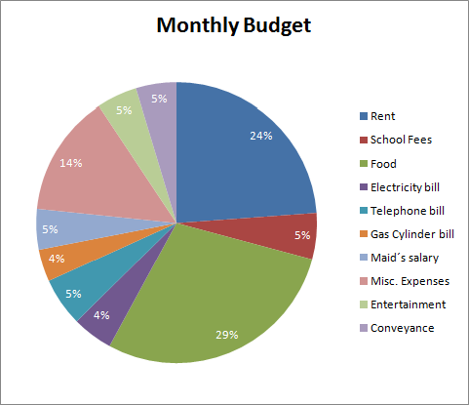

List all the sources of income (For example, Salary, Rent, etc.) and probable expenses in the following table and plan your monthly budget.

INCOME |  | EXPENDITURE
Particulars | Amount  (in Rs.) | Particulars | Amount (in Rs.)

TRY IT OUT
A. TYPE COLUMN HEADINGS FOR YOUR BUDGET
- Start the spreadsheet software and open a new blank sheet. (See Spreadsheets Skill 1.1)
- Type a title for your budget in cell A1. (See Spreadsheets Skill 4.1)
- In the cells below, type column headings “Income”, “Expenditure”, “Particulars”, “Amount (in Rs.)”. (See Spreadsheets Skill 4.1)
- Make the headings bigger or smaller. (See Spreadsheets Group 2 and Skill 5.2 )
4.5
- Change the look of the words. (See Spreadsheets Skill 5.1, 5.3 and 5.4)
- Change the alignment of the words. (See Spreadsheets Skill 5.7)
- Save your work in the Spreadsheet folder created in Module 2. (See Spreadsheets Skill 1.8)

B. TYPE THE AMOUNTS FOR YOUR BUDGET
- In the cells below the column labels, type the amount for income and expenditure that you had planned in the table. (See Spreadsheets Skill 4.1)
- Save your work.

C. MERGE COLUMN HEADINGS
  - Merge cells with the column headings of your budget title, “Income” and “Expenditure”. (See Spreadsheets Skill 5.10)
  - Save your work.

D. FORMAT NUMBERS
Format the numbers so they show as decimal. (See Spreadsheets Skill 4.9)
E. CHANGE THE APPEARANCE OF YOUR SHEET
- Change the height and width of cells. (See Spreadsheets Skill 5.5 and 5.6)
- Add a background colour and effects for cells. (See Spreadsheets Skill 5.9)
- Save your Work.

F. ADD TEXT IN THE CELLS
- In the cells below the total, type “Savings”, and “Percentage of total income”. (See Spreadsheets Skill 4.1)
- Save your work.

G. ADD FORMULAS IN YOUR BUDGET
- Insert a sum function to total the income and expenditure. (See Spreadsheets Skill 7.1)
- Insert a formula to show the savings. (See Spreadsheets Skill 7.4)
- Insert a formula to show the percentage of total income. (See Spreadsheets Skill 7.6 and 4.9)
- Save your work.
4.7

H. ADD A CHART IN YOUR BUDGET
- Create a chart using the wizard. (See Spreadsheets Skill 8.2)
- Change the look of words and numbers in the chart. (See Spreadsheets Skill 8.5)
- Change the colour of slices in chart. (See Spreadsheets Skill 8.8)
- Save your work.

Activity 4: Using what I learnt
In this activity you will discuss the uses of Spreadsheets software in your daily life. The software has many uses. For example, you can use Spreadsheets for making
- Surveys
- Shopping List
- Expense Sheets
- Accounts and Balance sheets

Think about other possible uses of Spreadsheets in your day to day life. Use the space given below to list the different uses of Spreadsheet.
____________________________________________________________________________________________________________________________________________________________________________________________________________________________________________________________________________________________________________________________________________________________________________________________
Share the list with your friends and note down any additional points.
____________________________________________________________________________________________________________________________________________________________________________________________________________________________________________________________________________________________________________________________________________________________________________________________

4.8

Activity 5: Self Practice
Practice your Spreadsheet skills by making samples using the Help Guide.
- Address Book
You can record the contact addresses in spreadsheet. The format of spreadsheet makes it easier to create and manage large number of addresses. Create your address book using the Help Guide.

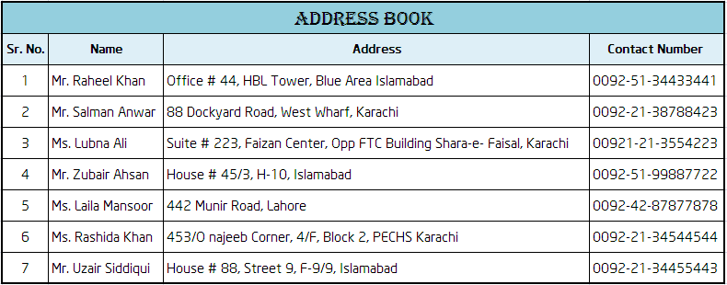
Address Book Example

- Inventory List
You can keep the stock of your inventory in a spreadsheet. Create an inventory list using the Help Guide.
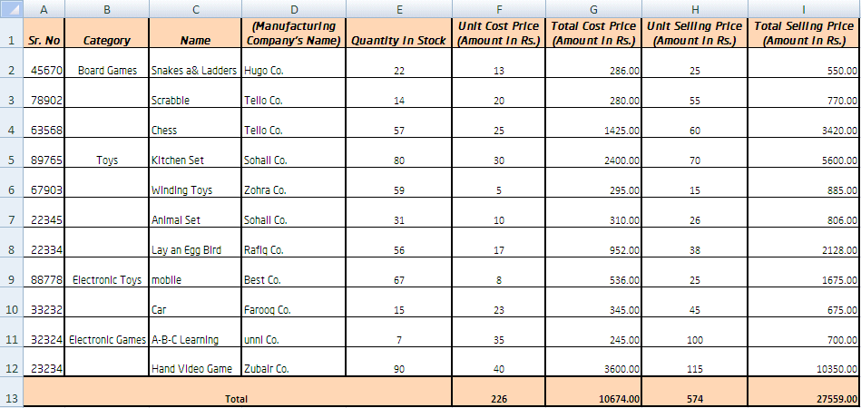
Inventory Example

Skills Set Checklist
4.9

Skills Acquired | Yes | No
I can enter and edit text and numbers in a Spreadsheet.
I can move around the spreadsheet.
I can perform simple calculation and apply a formula.
I can combine and merge cells.
I can format cell and change height and width of rows and columns.

I can create chart and define chart type.
I can save a Spreadsheet.

4.10

Module 5
Introducing Multimedia
Description: Sometimes, merely words are not enough to express our ideas and thoughts. A visual presentation with examples, pictures, diagrams, sounds etc. can be more effective to communicate. Multimedia is used to communicate and deliver information, ideas, reports, etc. to a large group of people efficiently and effectively.
In this module, you will explore Multimedia software in detail. You will develop multimedia skills by creating presentations that will be helpful in your daily life. You will use the Intel® Education Help Guide to help you do tasks on computer.

Activity 1: Exploring Multimedia
Before you learn to use Multimedia software using the Help Guide, spend a few minutes exploring the software on your own. Try to complete the following tasks:
- Find the Multimedia software and open it
- Insert a Title slide. Type something as the title.
- Insert two more slides. Include pictures and text in these slide
- Add sound effects and animation to the slides
- View the slides as a Slide Show
Answer the following questions once you complete the exploration:
- Were you able to complete the tasks? What skills did you learn?
____________________________________________________________________________________________________________________________________________________________
- What kind of activities can you do using the Multimedia software?
___________________________________________________________________________________________________________________________________________________________

- Compare Multimedia software to using a flip chart for a presentation? Which is better? Why?
__________________________________________________________________________________________________________________________________________________________________________________________________________________________________________
5.1

Share your answers with the rest of the class and note down points shared by your friends.
_______________________________________________________________________________________________________________________________________________________________________________________________________________________________________________________________

Activity 2: Getting to know Multimedia presentation using the Help Guide
Follow the steps to explore Multimedia skills in the Help Guide:
- Insert the Help Guide CD in the CD Drive and wait for auto run.
- Select “Open folder to view files”, and click OK.
- Double click Help Guide folder.
- Double click Help Guide.exe to start the application.
- Click the Multimedia link on the left navigation pane.
- What are some of the listed skills?
___________________________________________________________________________________________________________________________________________________________________________________________________________________________________________________________________________________________________________________________________________________________________
- Click Getting to Know Microsoft PowerPoint* (See Multimedia Group 1)
- What are some of the listed options?
_____________________________________________________________________________________________________________________________________________________________________________________________________________________
5.2
- Open a new presentation (See Multimedia Skill 1.1)
Note: To view individual steps while you work, click the serial number of the skill. Click Return at the bottom of the individual pop up window to come back to the main window.

- View the different toolbars. (See Multimedia Skill 1.2, 1.3, 1.4 and 1.5)
- Notice that a presentation has some unique elements identified in the table below.
Slide: | The white rectangular area on the screen is called the slide, which is the basic component of a presentation. A presentation can contain any number of slides, just as a book can contain any number of pages. Slides can contain text, pictures, charts and tables. You can also include animation (moving pictures) effects, audio and video clips to the slides in the presentation.
Outlines: | An outline is a text-only version of the entire content of a presentation. The text is indented according to the levels of headings, subheadings and running text. These are useful for editing and rearranging the text in the slides.
- Notice that your new presentation has by default opened a Title Slide.
- Type your name in title text box and your address in subtitle text box. (See Multimedia Skill 5.2)
- Insert a clip art in the slide. (See Multimedia Skill 6.1)

5.3
- Apply a design template to make your slide and make the presentation look good. (See Multimedia Skill 4.1)
- Insert a new slide with space for title, text and picture. (See Multimedia Skill 3.1)
- Type “My City” as title, the name of your city in the text box and insert an appropriate picture. (See Multimedia Skill 5.2 and 6.2)
- Change the font colour of the name of your city in the text box. (See Multimedia Skill 5.9)
- Change the font type of the name of your city in the text box. (See Multimedia Skill 5.6)
- Change the font style of the name of your city in the text box. (See Multimedia Skill 5.8)
- Play the presentation. (See Multimedia Skill 9.4)
- Notice that the presentation runs just like the slide shows through slide projector. The difference is the presentation is broadcast through a computer instead of a slide projector.
- Click the Close button to close the presentation.
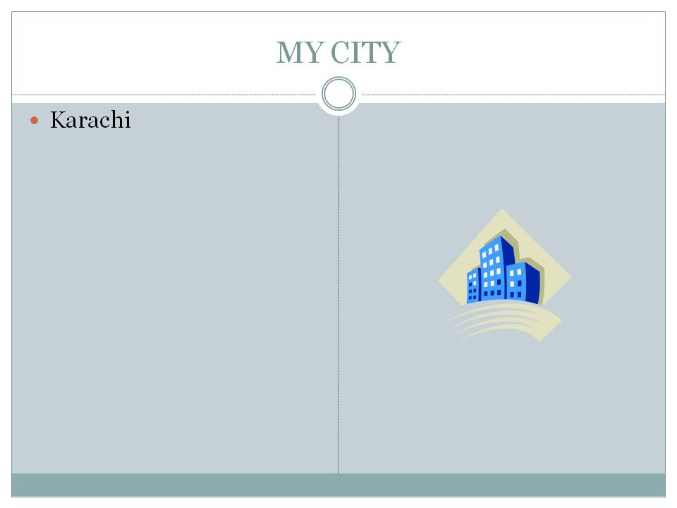

Activity 3: Using Multimedia Skills
You will have an opportunity to develop Multimedia skills as you complete the sample in the Guided Practice section and create samples in Self Practice section later.

Guided Practice: Introducing Myself
In our day to day life, we introduce ourselves with the use of words. In this activity you get an opportunity to create an “Introducing Myself” presentation.

5.4

PLAN IT OUT
Create an “Introducing Myself” presentation to share your hobbies, personal details, likes, dislikes etc. with others. Look at the following sample.
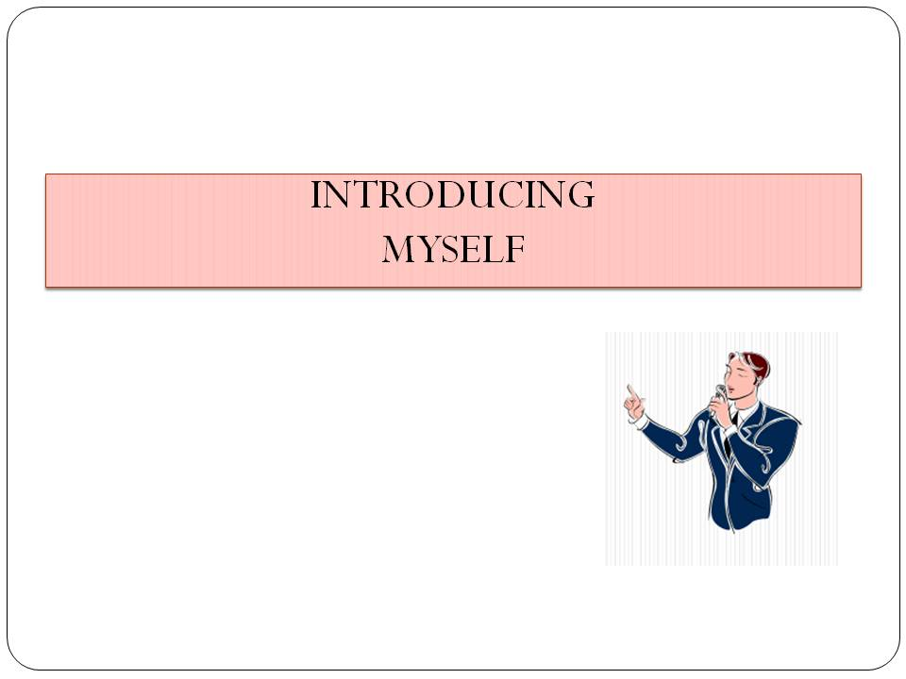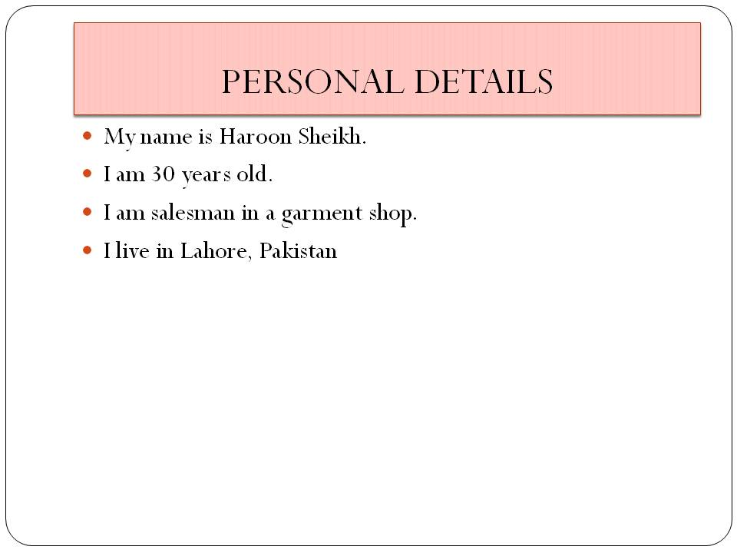
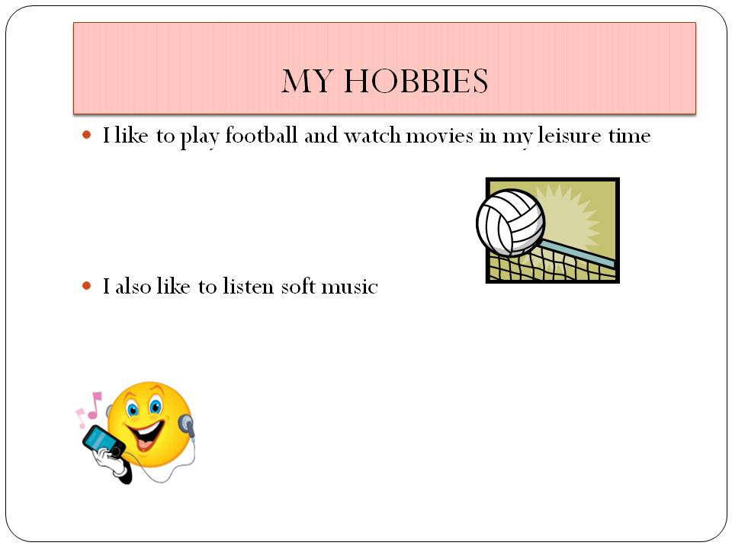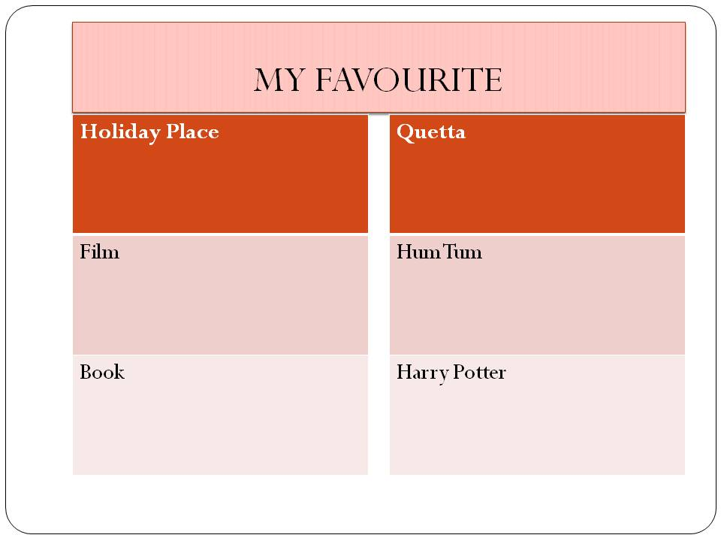
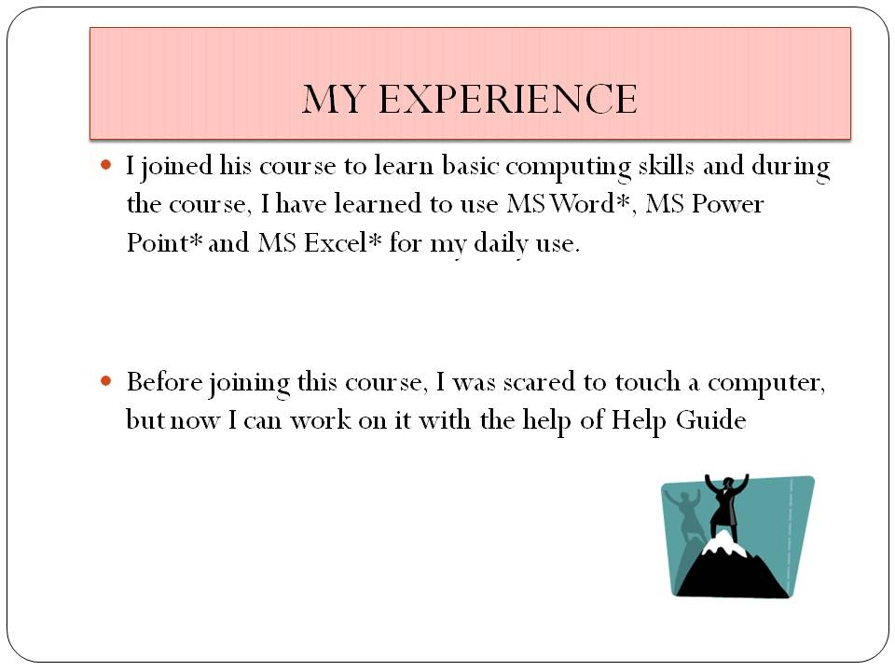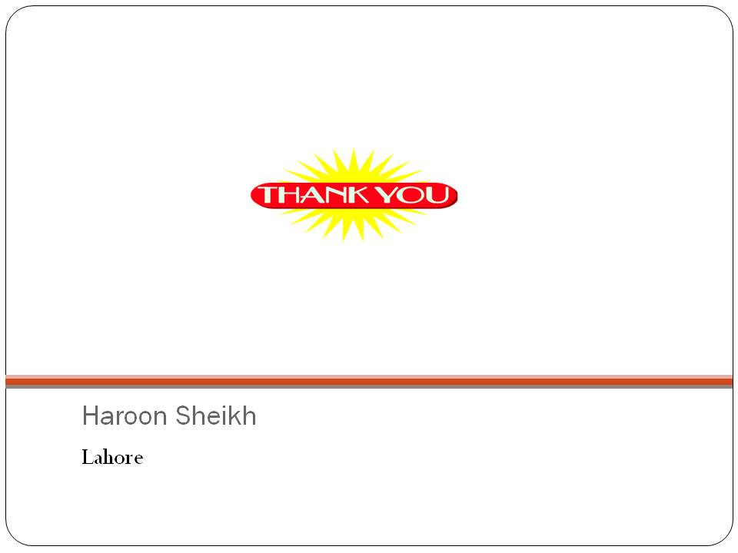

5.5

Plan your presentation using the space below. You may consider the hints provided in each slide.

Slide 1: Presentation Title
Title:

- Do you want to insert a clip art? If yes, what kind of clip art would you like to insert? ______________________________________________________
- Do you want a subtitle? If yes, what would it be?
_________________________________________________

Slide 2: Personal Details
<Title> (For example, I am …., personal details, Know me, etc.)
- Name:_______________________________________________
- Age:_________________________________________________
- Where do you live? ___________________________________
- Occupation:__________________________________________
- Qualification:_________________________________________
- Do you want to insert a clip art? If yes, what kind of clip art would you like to insert? _________________________________________________

Slide 3: My Hobbies and Interests
<Title> (For example, I like to…, My Hobbies, My interests, etc.)
- Describe your hobbies
________________________________________________________________________________________________________________________________________________________________________________________________________________________________________________
- Do you want to insert a clip art? If yes, what kind of clip art would you like to insert? _________________________________________________

5.6

Slide 4: My Favourite

<Title> (For example, My Favourite, I like to, etc.)
- Describe your favourites (For example, favourite actor, dish, poet, novelist, artist, holiday destination, sport, etc.)
_____________________________________________________________________________________________________________________________________________________________________________________________________________________________________________________
- Do you want to insert a clip art? If yes, what kind of clip art would you like to insert? _________________________________________________

Slide 5: Experience of doing this Course

<Title> (For example, My Experience, My Journey, etc.)
- Describe your experience.
(For Example, I liked ………………, I learnt…..., It was difficult to ……………………, etc.)
________________________________________________________________________________________________________________________________________________
- Do you want to insert a clip art? If yes, what kind of clip art would you like to insert? ______________________________________________________

Slide 6: Concluding Slide

- You may want to conclude your presentation by some quotes, thank you, etc.
- How do you plan to conclude your presentation?
__________________________________________________________________________________________________
- Do you want to insert a clip art? If yes, what kind of clip art would you like to insert? ______________________________________________________
- ___________________

5.7

TRY IT OUT
A. ADD A TITLE TO YOUR SLIDE
- Start the multimedia software and open a new blank presentation. (See Multimedia Skill 1.1)
- In the title text box, type a title for your presentation. (See Multimedia Skill 5.1, 5.2)
- Make the words bigger or smaller. (See Multimedia Skill 5.7)
- Change the look of the words. (See Multimedia Skill 5.6, 5.8 and 5.9)
- Save your work in the Multimedia folder created in Module 1. (See Multimedia Skill 1.9)

B. DESIGN YOUR SLIDE
- Change the slide layout. (See Multimedia Skill 4.4)
- Select a design template from your computer. (See Multimedia Skill 4.1)
- Select a colour scheme. (See Multimedia Skill 4.2)
- Select a background colour. (See Multimedia Skill 4.3)
- Save your work.
C. ADD A PICTURE TO YOUR SLIDE
- Add a picture to your slide. There are two ways you can insert pictures:
- Draw your own picture with the use of drawing tools. (See Graphics Group 5)
- You can add a picture from clipart or from file. (See Multimedia Skill 6.1 and 6.2)
- Save your work.

D. INSERT A NEW SLIDE
- Insert two new slides with a box for a title and another box for a picture. (See Multimedia Skill 3.1)
5.8
- Type your personal details and your hobbies. Add appropriate pictures. (See Multimedia Skill 5.1, 5.2, 6.1 and 6.2)
- Add border, 3D effects and shadow effects to your picture or clipart if you desire. (See Multimedia Skill 6.3, 6.5 and 6.6)
- Save your work.
E. ADD A TABLE TO YOUR PRESENTATION
- Insert a new blank slide. (See Multimedia Skill 3.1)
- Add or insert a table into a slide. (See Multimedia Skill 5.10)
- Type about your favourites in the table. (See Multimedia Skill 5.2)
- Make your table look good. (See Multimedia Skill 5.11)
- Save your work.
F. ADD MORE SLIDES
- Insert two more slides. (See Multimedia Skill 3.1)
- Change the slide layout. (See Multimedia Skill 4.4)
- Type your experience about the course. Add appropriate pictures. (See Multimedia Skill 5.2, 6.1 and 6.2)
- In the concluding slide, include the information you had planned earlier. (See Multimedia Skill 5.2, 6.1 and 6.2)
- Save your work.
5.9

G. ADD SOUND AND MOVIES IN YOUR PRESENTATION
1. There are four ways to add sound in your presentation.
- You can add sound or music from the clip organiser. (See Multimedia Skill 7.1)
- You can add sound or music saved on your computer. (See Multimedia Skill 7.2)
- You can also play audio track in your presentation. (See Multimedia Skill 7.3)
- Record voice for your presentation. (See Multimedia Skill 7.4)
2. You can add Movies in your presentation by following two ways.
- You can add movie from the clip organiser. (See Multimedia Skill 7.6)
- You can add movie saved on your computer. (See Multimedia Skill 7.7)
3. Save your work.

H. ADD ANIMATION AND SLIDE EFFECTS IN YOUR PRESENTATION
1. Add effects plays between the slides. (See Multimedia Skill 8.1)
2. Add animation or movement to an object. (See Multimedia Skill 8.3)
3. Add animation effects to words. (See Multimedia Skill 8.4)
4. Set the order and timing of animation on the slide. (See Multimedia Skill 8.13)
5. Save your work. (See Multimedia Skill 1.9)

Activity 4: Using what I learnt
5.10
In this activity you will discuss the uses of Word Processing software in your daily life. The software has many uses. For example, you can use Multimedia presentations for making
- Business Reports
- Family Functions
- Teaching Children
- Awareness Programs

Think about other possible uses of Multimedia presentations in your day to day life. Use the space given below to list the different uses of Multimedia presentations. _______________________________________________________________________________________________________________________________________________________________________________________________________________________________________________________________________________________________________________________________________________________________________________________________________________________________________________________________________

Share the list with your friends and note down any additional points.
________________________________________________________________________________________________________________________________________________________________________________________________________________________________________________________________________________________________________________________________________________________________________________________________________________________________________________________________________

5.11

Activity 5: Self Practice
Practice your Multimedia skills by making samples using the Help Guide.

- My Family
Introduce your family to your friends and relatives by creating “My Family” Presentation.
My Family Example
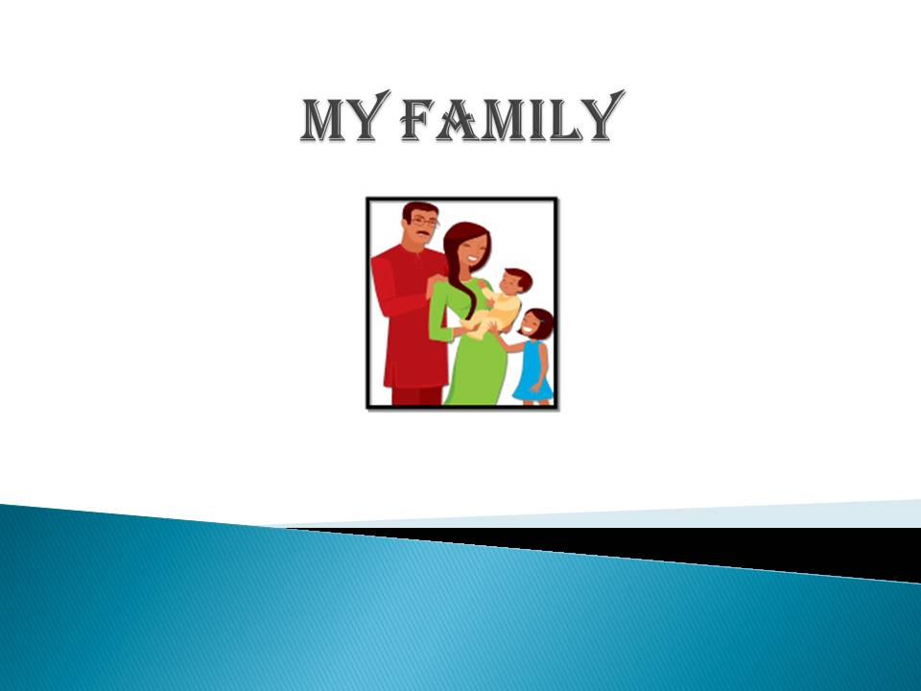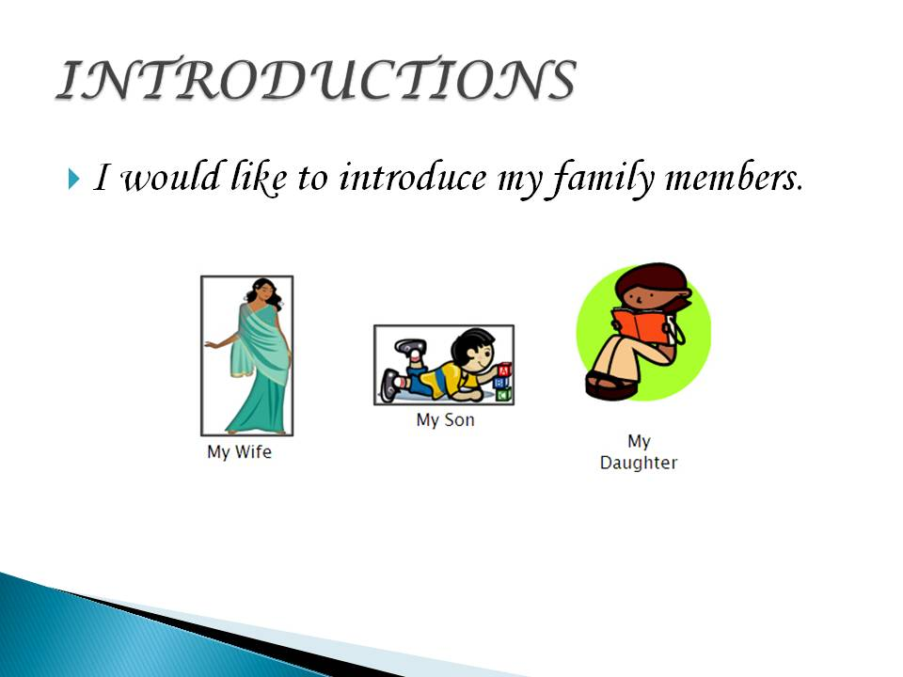
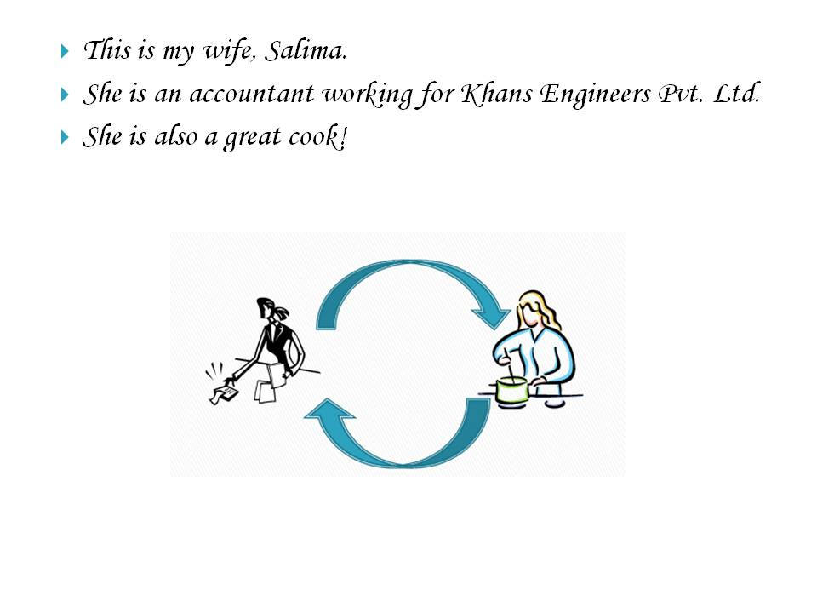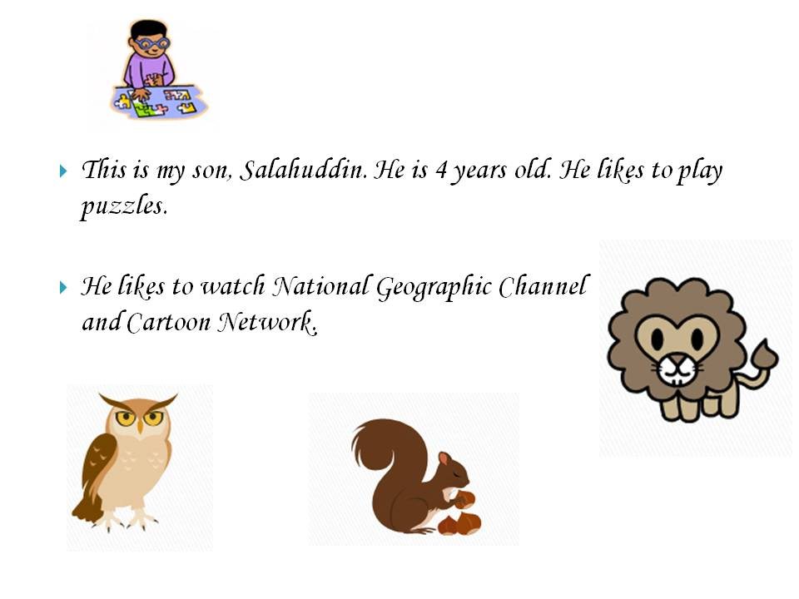
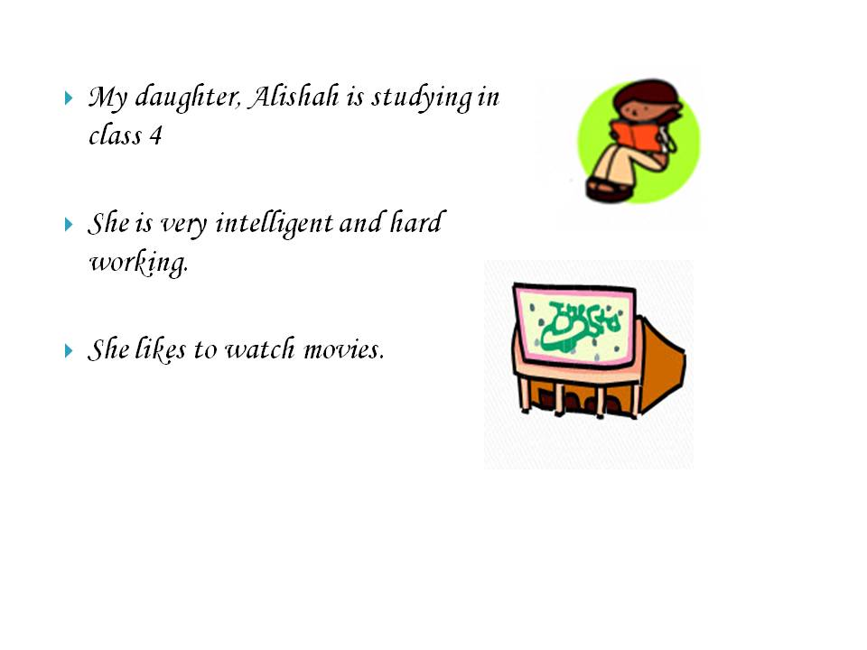
5.12
- Annual Function
5.12
Community annual functions are very common and essential part of our daily life. Create a presentation to share different events organized by your community throughout the year.
5.12
5.12
Annual Function Example
5.12
5.12
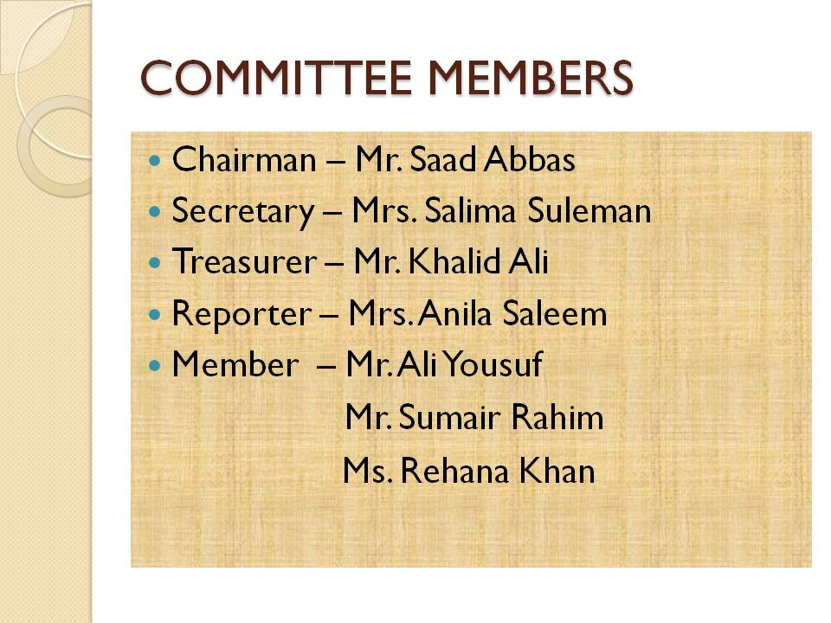
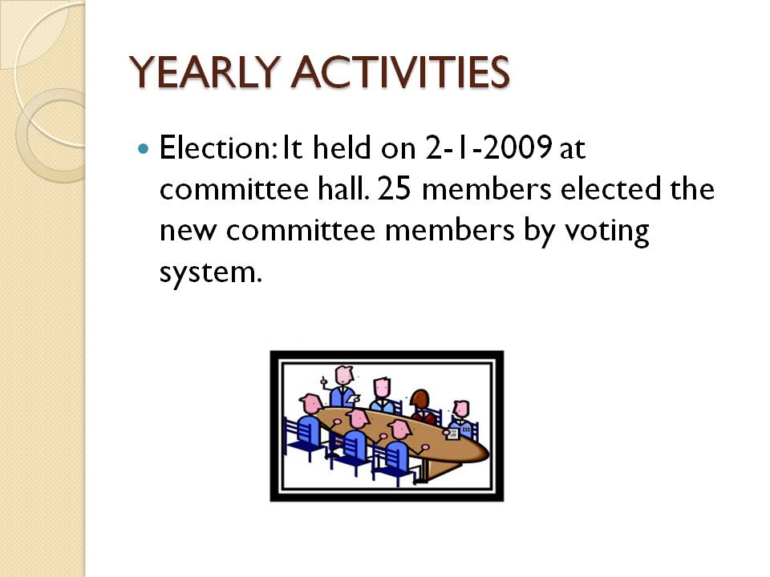
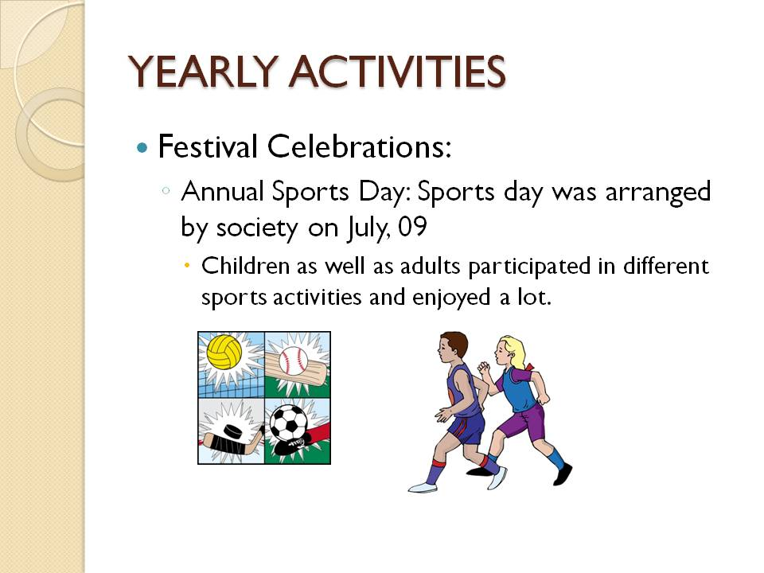

5.1
5.12
5.13
Skills Set Checklist

Skills Acquired | Yes | No

I can create a new presentation.

I can create slides with various layouts.

I can edit slides.

I can apply design templates to slides.

I can insert picture and clipart to slides.

I can insert a table in slides.
I can apply animation.
I can save a presentation.
I can start a slide show.
5.14

